Login page:

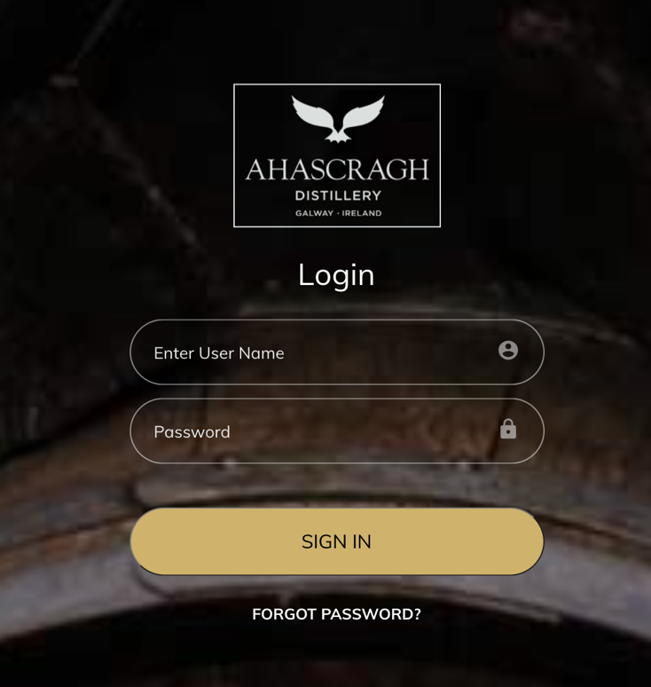

- No square around logo and increase size
- Square boxes around fields
- Square button

Wordpress page:

- Gotham font throughout
- Video to left of progress bar with option to click through gallery of images also
- All buttons should be gold, square, black font, in capitals including “Invest now” “Enquire now”
- Gold progress bar
- Black font – “target amount/invested amount/invested users”
- No need for logo on banner image as it should be top left of the page anyway
- Add heading “Our Plans” before “While living in Asia…”
- Organic architects also gets a profiler

- At the end there should be a bar with the benefits similar to Crowdcube:

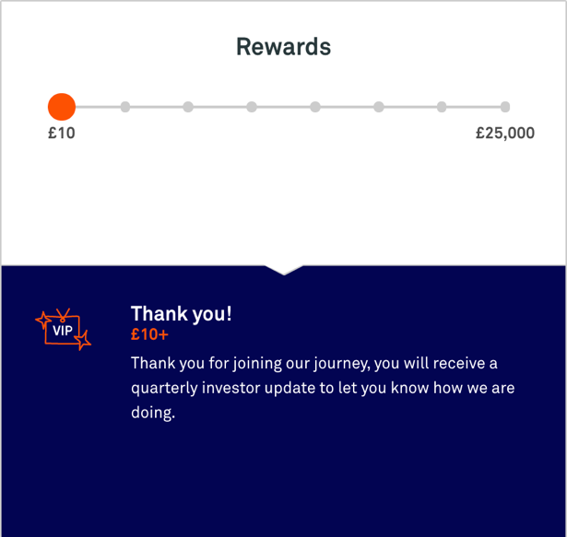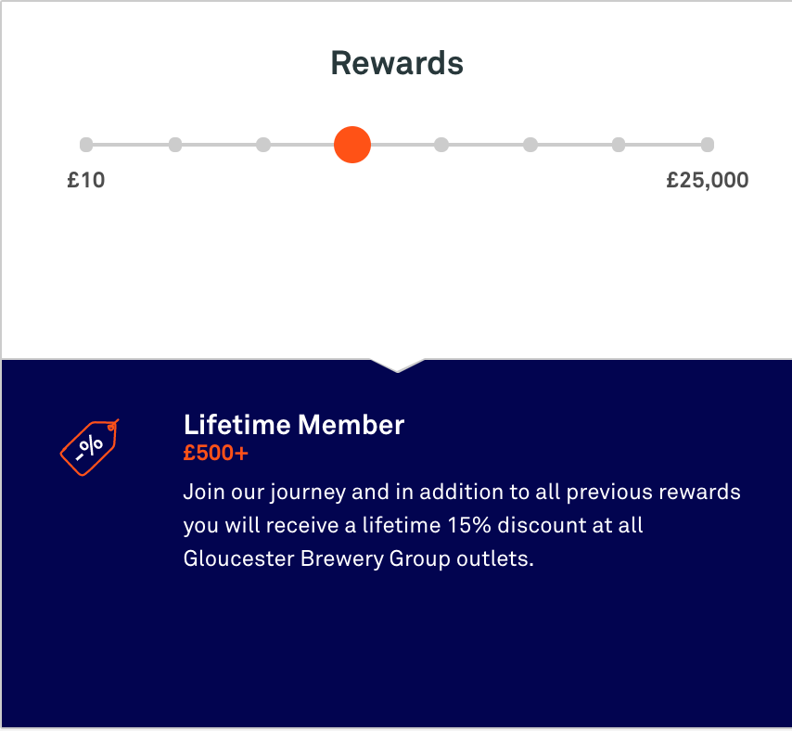

- Documents should be Downloadable pitch deck document and FAQs (will send both on)

- Can we add: Our team are ready to guide you through the process, if you have a question don’t hesitate to contact us at invest@ahascraghdistillery.com.

Dashboard

Should look the same as the dashboard for the shop

Change line to “Click my investments to invest in Ahascragh Distillery and be part of the Clan”

User/Admin Pages

- Gotham font
- No blue box at the top or make it gold
- Instead of Ahascragh in blue font it should be our logo
- Menu top left should be in gotham and black/gold – “Dashboard/Investment/My Investment” etc.
- If you click Dashboard in the mune top left it says “ 404 Page Not Found”
- Navigation Menu left should be gotham
- All buttons should be Black font and capslock
- All headings in Gotham, Black and Capslock – no blue headings

User – Investment page
- Can “Add Investment” be the landing page after people come in via the dashboard
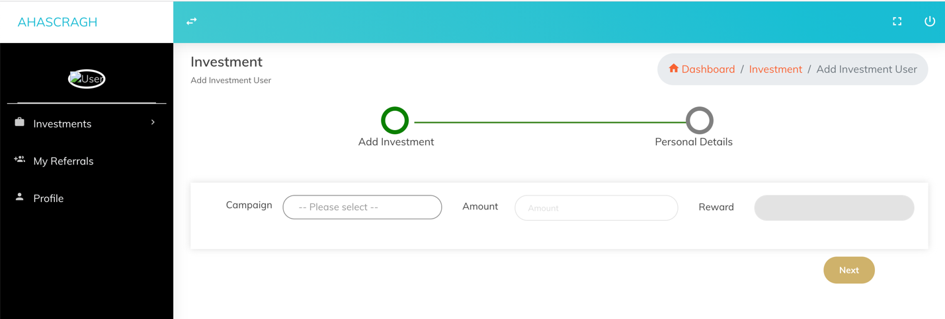

- There should be an icon per reward level e.g. an icon for water, an icon for barley etc. Then the list of benefits under that reward can just be listed. There’s no need for an icon per benefit.

- Under payment details – card should be the default rather than bank
- Can we add full address fields with Eircode – important as we need to post their rewards
- Typo on “referred”
- Change the gold text to
- Transfer the money to Ahascragh Distillery bank account
- Provide transfer reference ID here
- Upload transaction receipt or screenshot of statement (You can upload this later)

- If you enter in the wrong card details by mistake all fields are clearer and you have to re-enter all details. Can this be fixed?

- How do I upload the my documents e.g. transaction receipt at a later stage?

Admin pages
- Put investment status in black font as it is hard to read right now
- When you reply to emails via ‘Notifications’ Are they sent from invest@ahascraghdistillery.com
Adding a campaign

- When adding a new campaign – what is/where is the Icon used? and is the feature image the hero image?
- Can we change it so there is an icon for each reward level (uisce, barley, single grain etc etc.) No need for an icon for every benefit.
- When you fill in all the details for a new campaign including all the rewards and benefits – when you press save and if you haven’t uploaded a required item e.g. icon, it deletes all your entries and you need to start again. Can we fix this?

